OS Exam IDATA2305

1. The Microsoft Word program which you use is a part of the Operating System kernel and not a part of the application program. **(2 points)**
2. Suppose the Random Access Memory of a computer is increased from 16 GB to 32 GB. Why does the speed of the program execution increases ? **(2 points)**
3. All the processes must be present in WHICH memory in order to be executed directly by the CPU? **(2 points)**
4. Why does the Operating System use logical addressing when it can just use physical addressing? **(4 points)**
5. External Fragmentation in memory allocation happens when: **(2 points)**
6. Consider the virtual page reference string 4 , 7, 6, 1, 7, 6, 1, 2, 7, 2. On a demand paged virtual memory system running on a computer system that has a main memory size of 3 page frames which are initially empty. Let LRU, FIFO and OPTIMAL denote the number of page faults under the corresponding page replacements algorithm policy. Then? **(6 points)**
7. What is the over-allocation issue in Demand paging? **(2 points)**
8. A. What is CPU scheduling and why CPU Scheduling is important for OS?

B. Define Waiting Time and Turnaround Time. **(6 points, 3 points each for both parts)**

1. Why are web servers multithreaded? Explain with the help of an example **(4 points)**
2. Consider the code

public class Counter {

protected long count = 0;

public synchronized void add(long value)

{

this.count = this.count + value; }

}

Consider two threads A and B call add function and complete their execution. If thread A passes value=2 and Thread B passes value=3.

What is the value of count when both the threads finish? **(2 points)**

11) A file is is created with permission rw-r--r-- in unix. What is the permission given to the OWNER of the file? **(2 points)**

12) In the figure below, five processes and their burst time are given. Assume non-preemptive scheduling is followed. Assume all the processes arrive at the same time T=0. If process P2 wants to complete its execution with minimum waiting time then which scheduling technique will be best assuming none of the process needs IO devices and why?

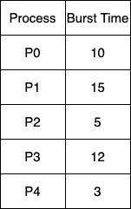

2) After the scheduling approach is followed, calculate and write what is the waiting time for process P2? **(4 points, 2 points each for both parts)**

13) In the figure shown below, There are three processes T1, T2 and T3. There are four resources R1, R2, R3, R4. Resources R1 and R3 have one instance of resource each, while resource R2 has two instances and R4 has three instances of resource. Also resources can not be preempted by the processes. Will the situation lead to deadlock and how ? Explain in detail with the help of four conditions related to deadlock. **(4 points)**

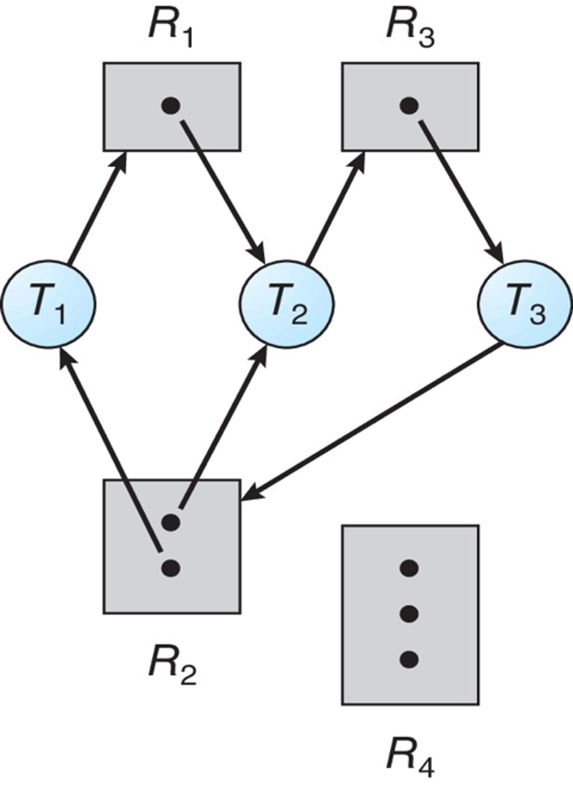

14) Logical Addresses are translated to physical addresses through a table called?

**(2 points)**

15)   
A. A file a.txt is created. If we create a hard link to this file and after that delete this original file a.txt, then the hard link will contain the same contents as file a.txt.

B. A file b.txt is created. If we create a soft link to this file and after that delete this original file b.txt, then the soft link will contain the same contents as file a.txt.

Ans: No

16) Which component of memory is not shared among the threads in a multithreaded process? **(2 points)**

17) Consider five processes shown in the figure below : Given the processes with Arrival time, CPU burst time and Priority (0 IS THE HIGHEST PRIORITY). PREEMPTIVE PRIORITY SCHEDULING is used for scheduling the processes. Calculate the average waiting time and average turnaround time if PREEMPTIVE PRIORITY SCHEDULING is applied. **(6 points, 3 points each for both parts)**

18) A. What is a Page Fault?

B. What are the fundamental steps used by the Operating System to handle the Page Fault?

C: How are Page Replacement Algorithms related to Page Fault? **(6 points, 2 points each for all three parts)**

19) There are 3 resources of type A, B, C shared by three processes P0, P1, P2. There is maximum 5 units of each resource types A, B and C.

Consider the figure shown where table name "Allocation" shows the number of units of each resource type allocated to each process and table name "Request" denotes number of units of each resource type requested by process in order to complete execution. What is the safe sequence to avoid deadlock? **(4 points)**

20) If a thread modifies a shared variable by adding value =2, then what is the correct order of execution by the thread in memory?

The column heading 1, 2, 3 shown in the figure shows the order of execution. 1 implies the instruction should be executed first. **(4 points)**

21) Answer these three questions:

1. What is the difference between seek time and rotational latency?

2. Why there is a need of disk scheduling algorithms?

3. Which algorithm selects the request with minimum seek time with current head position?

**(4 points, 1.5 points for first two parts, 1 point for third part)**

22) Consider the queue with disk heads as 98, 183, 37, 122, 14, 124, 65, 67.

The Head starts at 53. The total disk head movement if SHORTEST SEEK TIME FIRST disk scheduling algorithm is followed is: **(4 points)**

23) File System is a way OS uses to store, organize, and manage files and directories on a storage device. **(2 points)**

24) 1. System calls code is executed in which mode? Kernel mode

2. APIs code is executed in which mode? User mode

25) What are the services provided by the Operating System. **(4 points)**

26) Which of the following process states can be changed by the operating system? **(2 points)**

Which of the following is an advantage of using base and limit registers in a computer system? **(2 points)**

27) Which of the following best describes multiprogramming? **(2 points)**

Ans: Running multiple programs on a single processor.

What is the primary benefit of multitasking? **(2 points)**

28) Which of the following is an example of a hardware interrupt? **(2 points)**

How are interrupts and exceptions different? **(2 points)**

29) Numerical problem on bankers algorithm. Why is bankers algorithm used? **(3 points)**